Parish bulletin announcements
We invite you to ask your parish to publish the following messages in its online or printed parish bulletin to promote Development and Peace — Caritas Canada’s Stand for the Land campaign. You can adapt these messages to suit your needs.
In the bulletin, please use the higher-resolution images available here.

One week before your workshop
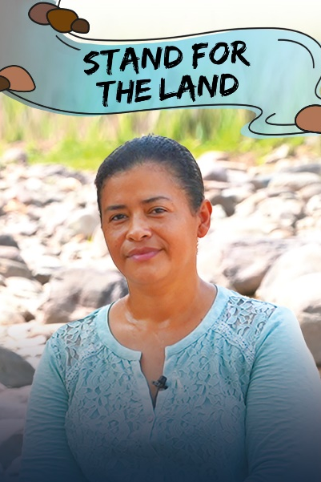
Workshop: Discover Development and Peace — Caritas Canada’s Stand for the Land campaign
This fall, we’re continuing the Create Hope: Stand for the Land campaign. This time, we’ll be meeting communities in northern Honduras who have been struggling to preserve their land and water since an iron ore mine opened in Carlos Escaleras National Park, and poisoned the rivers on which they depend for their livelihoods.
“We live every day with the fear of being killed or having one of our children taken away.”
― Juana Zúniga, member of the Committee for the Defence of Common and Public Goods of Tocoa, Colón
To learn more, join us for a workshop at [TIME] on [DATE] at [PLACE].
For more information, contact: [CONTACT NAME and CONTACT INFORMATION] or visit devp.org/campaign.

One week before the launch of the campaign in your parish
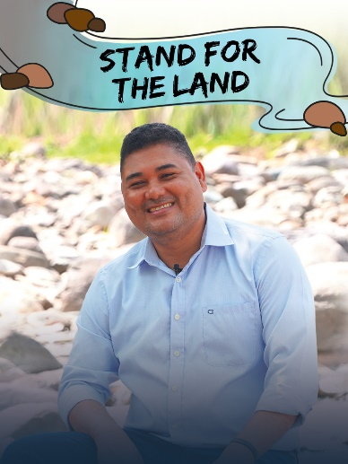
Let’s Stand for the Land!
For Development and Peace — Caritas Canada’s Create Hope : Stand for the Land campaign, our partner ERIC–Radio Progreso has asked that we support the defenders of human rights and the environment in Honduras. Since 2015, the communities of Guapinol and the San Pedro sector have been fighting to preserve their rivers and the Carlos Escaleras National Park from mining. To find out more, visit devp.org/campaign.

“Communities are displaced. Rights are violated. Access and rights to water denied. All this to give priority to the extraction and pillaging of resources.”
― Leonel George, member of the Committee for the Defence of Common and Public Goods of Tocoa, Colón

Stand in solidarity. Sign the letter
to the Honduran ambassador to Canada at devp.org/act.

The week of signing the petition
Together, let’s support the communities of Guapinol and San Pedro in Honduras!

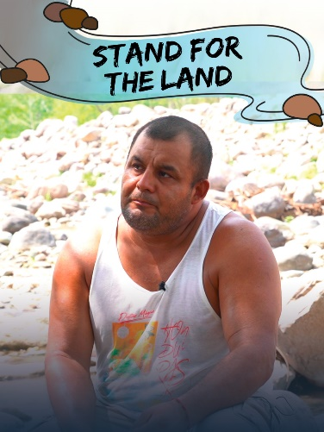
Development and Peace ― Caritas Canada is responding to the call from our partner ERIC–Radio Progreso to raise awareness of the tragic plight of the communities of Guapinol and the San Pedro sector. We stand with them as they defend their right to water for survival and struggle to obtain:
- Justice
- Reparations and protection
- The cancellation of irregularly granted mining permits
- The restoration of their national park

“It is urgent to cancel all mining in this area of our park. All the damage caused to our rivers and mountains must be repaired.”
― Daniel Márquez, Guapinol defender and former political prisoner

Let’s ask the Honduran government to better protect environmental and human rights defenders and to act for justice. Stand in solidarity. Sign the letter to the Honduran ambassador at devp.org/act.

One week after signing the petition
Let’s heed the cry of the Earth and the cry of the poor and let’s act!
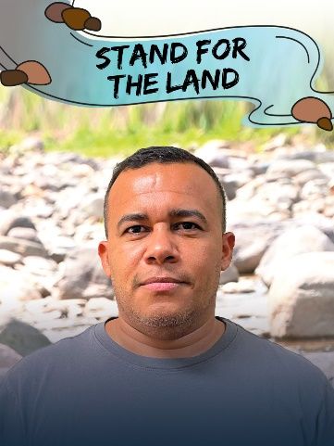
Pope Francis calls us to hear “the cry of the earth and the cry of the poor” (Laudato Si’, 49). Yet, since 2015, the communities of Guapinol and the San Pedro sector have been trying in vain to be heard. In their struggle for justice, defenders are attacked, criminalized and even killed. Eight defenders were unjustly imprisoned for over two years, and three people have been murdered since January 2023.
“The Government of Honduras must act diligently and suspend these extractive activities, which are carried out illegally and with total disregard for the environment.”
― Elvin Hernández, human rights investigator, ERIC–Radio Progreso
Act now!
Sign the letter to the Honduran ambassador to Canada asking her government for protection, justice and reparation for environmental defenders and for Carlos Escaleras National Park (devp.org/act).

If you’d like to organize a garbage clean-up
Clean up the land! Connect local action with global solidarity.
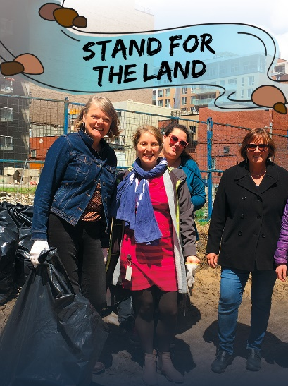
We’re responding to Development and Peace ― Caritas Canada’s call to organize a clean-up in our community in solidarity with environmental and human rights activists fighting to preserve their land, water, culture and lives.
Together, let’s care for the Earth, our common home. Join us on [DATE] for a clean-up event starting at [TIME and PLACE].
Bring your work gloves, wear closed shoes and weather-appropriate clothing! For more information, contact: [CONTACT NAME and CONTACT INFORMATION].
If you can’t join us but would like to organize a clean-up in your community, find out more at devp.org/campaign.

As the campaign comes to an end
Thank you for standing for the land
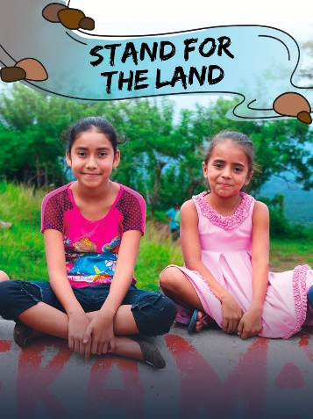
Thousands of Canadians signed the letter in solidarity with our sisters and brothers in Honduras who are protecting their water and fighting for their rights.
The Create Hope – Stand for the Land campaign aims to collect 32,000 signatures by February 25, 2024. A delegation of Development and Peace ― Caritas Canada members and staff will then meet with the Honduran ambassador to Canada to show our support and solidarity.
On behalf of all those struggling to preserve their land, their water, their culture and their lives, Development and Peace ― Caritas Canada thanks you for your continued commitment and mobilization. Together, we are building a world of justice.
- To sign our petition and to continue supporting our campaign, visit devp.org/act.
- To become a member and support our mission, visit devp.org/joinus.

