PARISH BULLETIN ANNOUNCEMENTS
To promote the Create Hope: Stand for the Land campaign, please request to have these 2023 Share Lent announcements from Development and Peace — Caritas Canada published in your parish’s bulletin. Ideally, the messages should be published over seven consecutive weeks, starting February 19, 2023.
For publishing in the bulletin, please use the higher-resolution images available here.
Pre-Lenten announcement: February 19
This Lent, let’s stand for the land
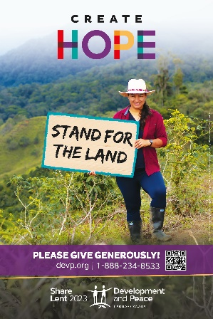
This year, Development and Peace — Caritas Canada’s Create Hope: Stand for the land campaign calls you to support our sisters and brothers in the Global South in defending their land and territory. Do this by:
- Donating online at devp.org/give or during the Solidarity Sunday collection on March 26, the fifth Sunday of Lent. Your generosity helps support over 86 projects in 40 countries around the world!
- Learning more by reading the Mini-magazine and other resources available at devp.org/lent/resources.
- Meet our solidarity visitors and participate in the campaign launch webinar on February 25 at 1:30 p.m. ET.
For more information, contact [Name of the local Development and Peace contact person] at [Telephone number] or [Email address].
Week 1: February 26
Development and Peace: a movement of solidarity
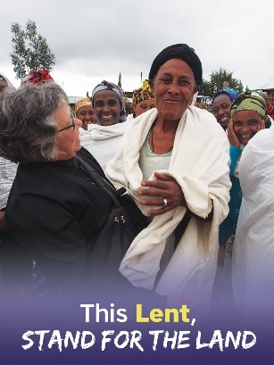
Established in 1967, Development and Peace ― Caritas Canada is the official international solidarity organization of the Catholic Church in Canada.
We partner with organizations in the Global South that promote alternatives to unjust social, political and economic structures and support women in their quest for equality and justice.
With the help of our 11,000+ volunteer members, we inform Canadians about the root causes of impoverishment and mobilize them to act for change. Our Lenten campaign, Stand for the Land focuses on people’s defence of their territories in Colombia and Honduras.
To learn more about our movement and to join us, visit devp.org.
Week 2: March 5
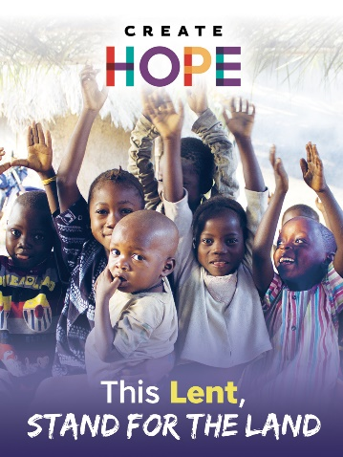
The courage to Create Hope
To delegates at the 4th World Meeting of Popular Movements, Pope Francis said, “…you have the ability and the courage to create hope where there appears to be only waste and exclusion.”
These are the words that inspired the choice of “Create Hope” as a five-year guiding theme at Development and Peace ― Caritas Canada.
The courage to Create Hope is rooted in actions big and small. For to drive away anguish and despair, it is best to act. Every action we take has a positive effect on us, our neighbours, our great human family, our children and their descendants. What will you to this Lent to Create Hope? Join our campaign at devp.org/lent.

Week 3: March 12
Colombia: defence of land and territory
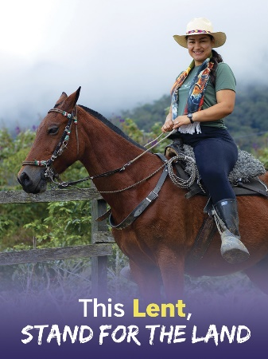
Colombia is home to nearly 10 per cent of the planet’s biodiversity, yet it is also one of the most dangerous countries for people defending their land and territory against exploitation.
Development and Peace ― Caritas Canada’s partner, the Asociación Campesina de Antioquia (ACA, Peasant Association of Antioquia) supports peasant communities affected by armed conflict in defending their lives and territories and in building a culture of peace through filmmaking and art.
This Lent, meet our solidarity visitor Raquel Soto, a participant in ACA’s documentary filmmaking school. Learn more at devp.org/lent.

Week 4: March 19
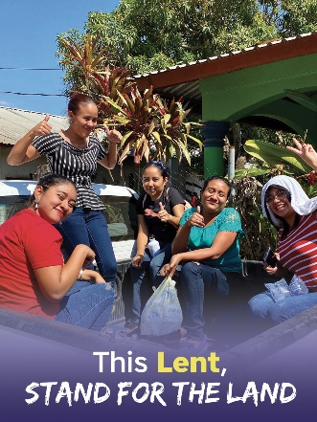
Standing for the Land in Honduras
Honduras’s diverse ecosystems, fertile lands and rich natural resources attract many profiteering enterprises that overexploit the land to no benefit for local communities.
Development and Peace ― Caritas Canada supports Equipo de Reflexión, Investigación y Comunicación (ERIC, Reflection, Research and Communication Team), an organization that helps communities in their struggle for land and territory and investigates human rights abuses.
This Lent, meet our solidarity visitor Elvin Hernández, a human rights investigator at ERIC. Learn more at devp.org/lent.

Week 5: March 26 – Solidarity Sunday
This Lent, please give generously
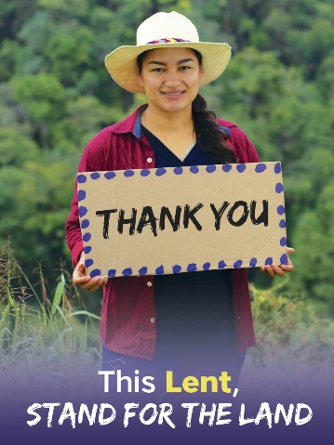
This Solidarity Sunday, Development and Peace ― Caritas Canada’s Stand for the Land campaign invites you to give generously and thanks you warmly for your generosity.
Your donation transforms the lives of some of our most vulnerable sisters and brothers across the world. Our solidarity rests on your generosity.
“The support we receive from Development and Peace has been very important for me. It allowed me to find myself, to live again.”
— Raquel Soto, participant in the documentary filmmaking school of the Asociación Campesina de Antioquia (ACA, Peasant Association of Antioquia)
Such is the difference you can make by giving to your Share Lent parish collection or at devp.org/give. Thank you for helping us build a world of justice.

April 2 (or as soon as the results of the fundraising campaign are known)
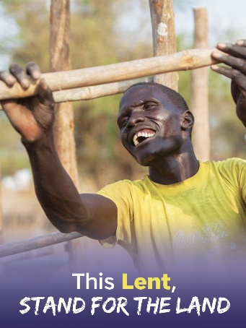
Thank you for giving from the heart to Share Lent 2022!
Development and Peace — Caritas Canada thanks you for supporting the People and Planet First campaign with your Share Lent donation. Thanks to your generosity, our parish collected [$ amount]. This sum will help support our sisters and brothers in Africa, Asia, Eastern Europe, Latin America and the Middle East.
If you have not had a chance to donate, there is still time to place your Share Lent envelope in the offertory or to donate online at devp.org/give.
Thank you for continuing to pray for all those who are working to build a world of peace and justice.

